
Census or Sample ?

Here are three important definitions

- POPULATION (census) – The entire group of people, animals or things about which we want information.

- SAMPLE – A part of the population from which we actually collect information which is used to draw conclusions about the whole population.

- CENSUS – This is when every member of the population has data collected from them

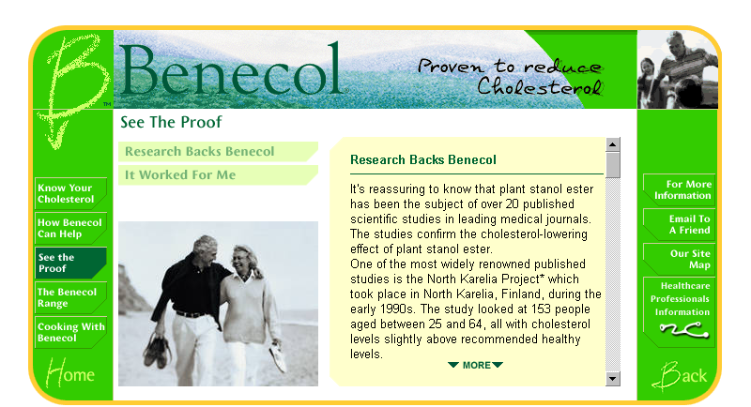
Most of the information we are given in number form is taken from samples not from the whole population.

Example
Look at this advertisement – It says
“Proven to reduce Cholesterol”,
but only 153 people were in the
sample it was tested on.

Discuss the size and makeup of samples
and try to find other examples of adverts
and newspaper Headlines.

Think about each of the following examples. Which of them would you study by sampling and why? How big should your samples be?

- Length of battery life.
- Accurate count of the number of people in the world
- Safety cords on parachutes
- The top ten pop songs this week
- Reasons for absence from school when the English football team is playing in the World Cup
- Safety crash tests on cars?

What might be wrong in using the following samples to describe the Australian people as a whole?
- Teenagers
- People whose names begin with P
- People using Brisbane Airport
- People in restaurants
- Every tenth person in the telephone directory.

